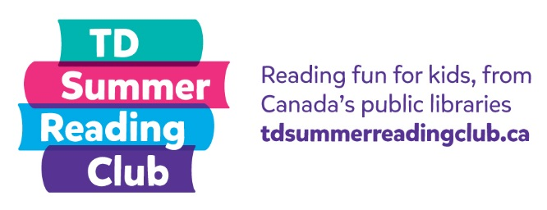
Reading report:
Fiction

Name: __________________ Age: _______

Title: _______________________________
Author: _______________________________

My rating:

Not so good OK Amazing!

Who was your favourite character in the story? Why?

What was the best part of the story?

