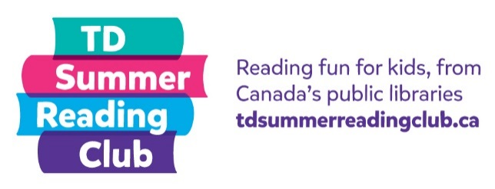
Reading report:
Non-fiction

Name: __________________ Age: _______

Title: _______________________________
Author: _______________________________

My rating:
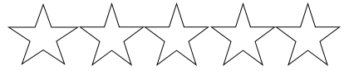

Not so good OK Amazing!

What was the weirdest, funniest, or most interesting fact you read in this book?

Why did y ou choose this book?

