Why and How: Family Journal
Having a group journal around is a great way to connect in a way that the entire family will love to look back upon. It can serve as your family’s history—a place to record milestones, share thoughts and aspirations, set goals; to recount family outings, vacations, holidays, and adventures – or just for fun.
- Have a journal in the car or when travelling.
- Create ongoing activities and sharing, like when out to dinner or at the park.
- Make waiting at the doctor’s office or a long drive go quicker by initiating a new questionnaire or wish list.
You can do anything you want in your family journal including
- stick pictures inside
- make pockets
- art of all kinds and types
- interesting happenings at school, work, during trips etc.
- lists of all kinds! Wish lists, favourites, places you want to go etc.
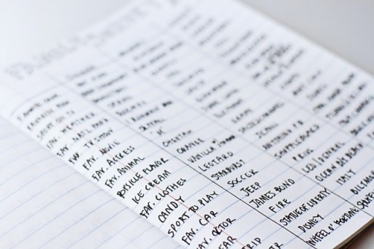
An example of a family survey.
On a family trip: “Plants in Charlotte”
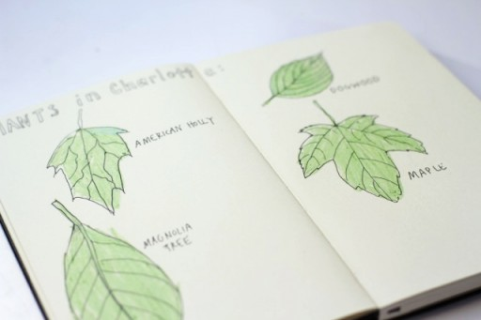

In these journals we can also track our family reading, our favourite books, books we want to read etc.
We will have sticker pages and when you return your book to the library and let us know you read it, you can get a sticker.
Each week during TD Summer Reading Club we will find more creative ways to make our journals special to us.
